Neighbourhood Farm

Name Tawira Valentine1,

1uwc, Robert Sobukwe, Bellville, 7535, South Africa

Tel: +2782 478 617 number, Email:kudatawira@gmail.com

2Hector Peterson residence, Belhar 8, Cape Town, 7493, South Africa

Abstract: The Food insecurity is one of the most complex global issue facing most developing countries especially in the poor marginalized communities. The use of ICTs to amplify food security is a recent question of interest. This proposal aims to implement ICTs in food security concentrating on the Neighbourhood farm initiative in the in the Deep South of Cape Town stretching from Muizenberg through to Kommetjie.

Keywords: Food Security.

# 1. Introduction

Food insecurity is a major global challenge in both developing and developed countries with its main effects being heavily felt in poor marginalized populations within these countries. Food security exists when all people, at all times, have physical and economic access to sufficient, safe and nutritious food to meet their dietary needs and food preferences for an active and healthy life (World Food Summit of 1996).With the African population being estimated to double by 2050[1], food security has become an area of interest that require much attention especially in the sub-Saharan region. Initiatives to support and encourage food security remain a key area of development across all communities. Recent statistics have proved that one of the main problems that accounts for food insecurity can be tracked to food loss and wastages [2]. Roughly every year, one third of the food produced in the world for human consumption, approximately 1.3 billion tonnes gets lost or wasted [3] .In this paper we propose the implementation of Information Communication Technologies (ICTs) to amplify and encourage food security at community level specifically focusing on the Neighbourhood farm initiative in the Deep South of Cape Town.

The Neighbourhood Farm initiative is a project that is committed to the development of community market gardens for the growing of organic crops at schools in the Deep South of Cape Town stretching from Muizenberg through to Kommetjie. The 17 schools in this area are a representative of the full economic spectrum, from well-resourced, to critically in need. With close to 15 000 children at these schools and over 100 000 community members, the Neighbourhood Farm believes that all of them have the right not only to access nutritious food but also the knowledge to grow it for themselves. The Neighbourhood Farm aims to build sustainable market gardens at each school that does not only bring a beautiful outdoor classroom but goes on to show children how food is grown. The market garden provides a small revenue stream from distributing and selling healthy food to both the school and the local community. This not only makes the gardens sustainable, but empowers the community through skills-based training and experience. The project also provides a market platform that can be used by the local producers from the community to sell their produces. In turn, these create further economic and entrepreneurial opportunities for marginalised community members.

# 2. Problem Statement

Efficiency in the operation of the Neighbourhood Farm initiative is one big stabling block that can threaten the effective management of the whole initiative. Most projects of similar structure usually fail because of uneconomically viable management and operations hence a crucial need for the neighbourhood farm initiative to operate effectively. With quite a number of players involved in the project operations, complex actions are likely to be experience in the areas of general management of the farms (schools) that include stock management and the analysis of data.

1. Stock Management Problem

The movement of stock in and out of the farm needs to be carefully managed and monitored. The management of stock is very significant in the successful operations of each farm and the entire project at large mainly because it influences decisions relating to the quantities that needs to be harvested, how much need to be requested from the other farms as well as how much can be transferred to the other nearby farms among other important reasons. Allowing third part producers to supply the farm with their produces as well as the option of requesting stock from other farms needs a very effectual stock management system to keep track of these different produces. Poor stock management system often results in the wastages and loss of the produces (food) which has been previously identified as one of the major contributors to food insecurity.

1. Data Analysis

Analysing data does not only add operational value through motivation but also goes a long way in making inferences about future performances. Problems are likely to be faced in efforts to determine the performances of products at farm level as well as at the project at large. The tracking of produces wastages and loss is also one potential problem that can potentially threaten the Neighbourhood farm project.

# 3. Related Literature Review

Revisiting the Fishers of Kerala, India (Janaki Srinivasan, Jenna Burrell)

The paper concentrated on finding out how the use of mobile phones for sharing market price information has made on the fish markets more efficient and the way it improved both fisherman and consumer welfare in Kerala, India. The whole study was framed around comparing two sites, one in north Kerala and the other in south Kerala. The research identified that fish trade in the north Kerala was somewhat a distinctive case with certain conditions which allowed fishers to sell their fish at different prices. It was noted that the findings in the north Kerala did not hold in south Kerala.

It was noted that the use of mobile phones gave the fisherman a wide choices in when marketing the fish. The use of mobile phones gave them more information pertaining market performances and demand.

# 4. Proposed Solution

Implementing ICTs to counter solve the problems that the Neighbourhood farm project will possibly face is one viable solution. Effective implementation of Information Communication Technology (ICTs) will not only solve the stipulated problems but will also enhance and improve the farming practices in the communities. Using Information Communication Technology to effectively manage the stock system and perform data analysis amplifies the management and operations of the whole initiative.

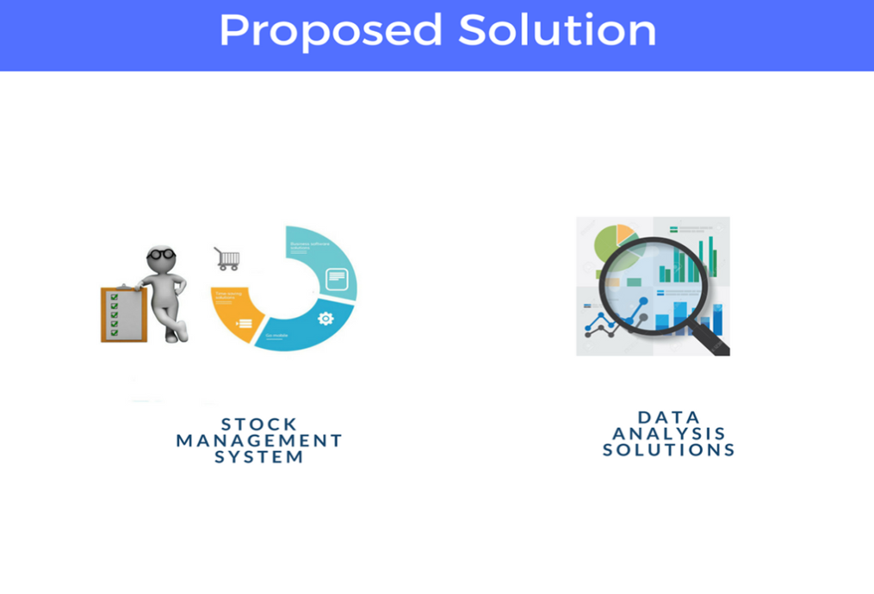

1. Stock Management System

The proposed stock management system aims to allow effective, productive and flexible stock operations between farmer, seller and third part players.

1. Data analysis

The proposed system aims to extract and analyse data from all parties involved in the operations of the project. The system will view product performances, track wastages and loss in produces among other critical data analysis solutions.

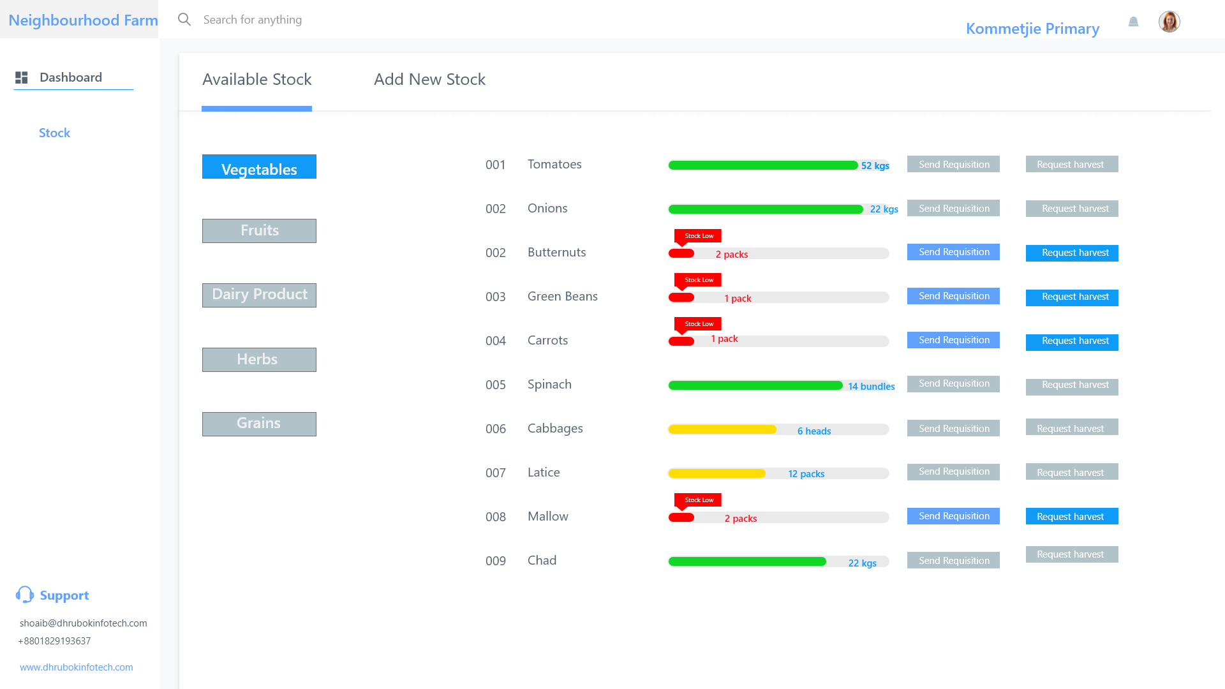

# 5. Methodology

The broader needs that need to be achieved are cleared up by the problem statement, however full involvement of the community in designing the required platform is critical and goes a long way in building a product that will not be shelved by the community members as a result of not meeting their personal needs and attentions. To address the possibility of such a problem to occur, plans to have a pilot survey of the neighbourhood community will be carried out to have a clear picture of the overall project. Meetings and interviews with the overall manager of the project has been and will be carried out to have full information on of the critical areas that need more attention.

The drawing up of use case diagrams of will ice break the development process .When a full understanding of the required has been well explained by the use case diagrams then the designing of a prototype will be carried out. Agile product development process will be used to allow effective communication between all the parties throughout the development. Process

# Conclusion

The use of ICTs can be of great benefit to the Neighbourhood Farm project especially in the area of stock management and data data analysis.

# References

[1]  Africa Check. (2018). SA minister got it wrong on Africa’s population growth | Africa Check. [online] Available at: https://africacheck.org/reports/sa-minister-got-wrong-africas-population-growth/ [Accessed 13 Apr. 2018].

[2] UNDP. (2018). Preventing waste, a recipe for food security | UNDP. [online] Available at:http://www.undp.org/content/undp/en/home/blog/2017/la-mejor-receta-es-no-desperdiciar-alimentos.html [Accessed 13 Apr. 2018].

[3] Food and Agriculture Organization of the United Nations. (2018). Key facts on food loss and waste you should know!. [online] Available at: http://www.fao.org/save-food/resources/keyfindings/en/ [Accessed 13 Apr. 2018].